# Professional capabilities

With a team of professionally trained chefs and business managers ,we pride ourselves in the products and services that we deliver and feel.

We are young ,energetic, enthusiastic and above all passionate about what we do distinctly.

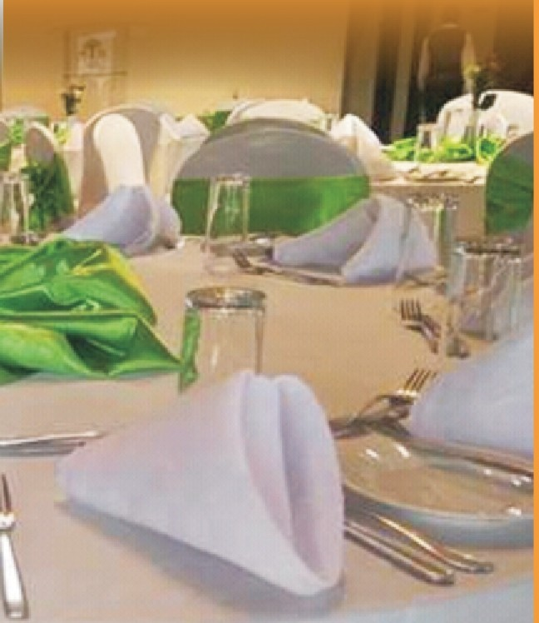

Rainhouse

**The**

Manager, Operations and business development

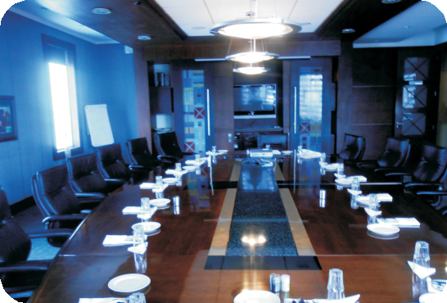

F& B

Ma na ger Ac co unt ant Ma na gin g Ch ef So us Ch efs Co oks

Waiters and waitresses Stewards

**Plant and Equipment** Motor vehicle,station wagon Baine Marie

Chafing dishes High

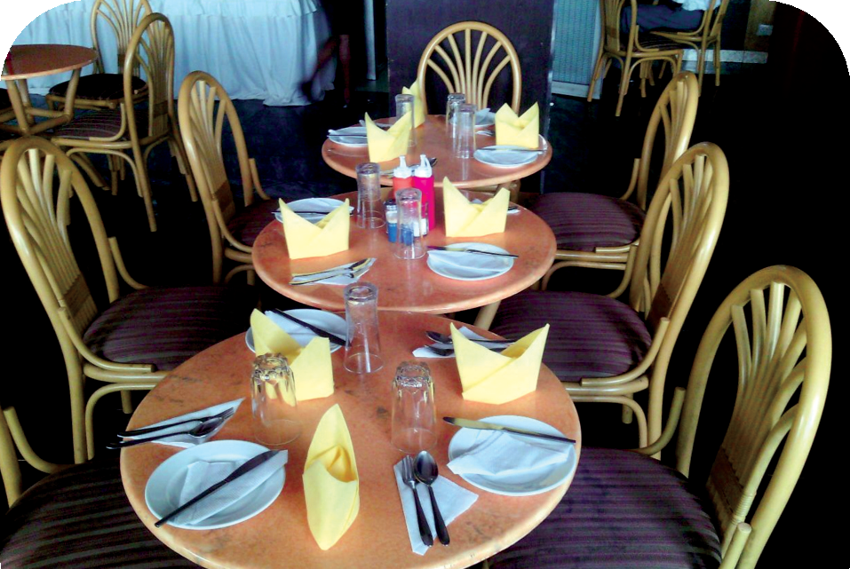

pressure gas stoves Conventional Gas oven Gas cylinders Deep

freeze rs Fridge s Conv ertible tables Plasti c chairs Linen and drape ry

Tents,dome shaped

P.A systems Cutlery and crockery Blenders and mixers Standby solar lighting unit Energy saver jikos

# Business Finance

We value your commitment and trust in us and would go all the way to establish convenient, accessible and user friendly terms and means of payment; you can pay either by cash,mpesa ,EFT or do short/long term supplier agreement upon negotiations based on time and value of business

# Your feedback

We get encouragement to continue in our pursuit of excellence by the positive and constructive criticism and complimentary feedback that we receive from our customers from time to time.

Feel free to share your experience with our services

# We are distinctly different always

While there are many catering and events service establishments around,*We are, and remain The Rainhouse,aromatically and distinctly different always.*

Aromatically Distinct

**Operations Office**

**Dreams House, Cross Road, Off Accra Road**

**P.O. Box 124-00625, Nairobi Tel: 0722 / 0788 345 734**

**Email:** [**Rainhousearoma@gmail.com**](mailto:Rainhousearoma@gmail.com)

# About Us

The Rainhouse is a catering, entertainment and events logistics facilitation company specializing in corporate and personalized service delivery that excites the customer distinctly.

Founded in the year 2014 and driven by the desire to offer unique, customized and exceptional quality food, entertainment and friendly logistics delivery at affordable costs that fulfils the desire, goal and intent of a customer through time and efficiency. The company's main focus of service delivery are in:

*\*Corporate catering*

*\*Personalized services*

*\*Staff Canteen leasing & management*

*\*Events and entertainment logistics*

*\*Training and Culinary skills development*

*\*Cakes and tantalizing snacks delivery*

# The Rainhouse, our Vision

We envision to be a company that is successful in the market and products/services leadership in our field by offering innovative and quality service streams.

This will be achieved by us being responsive to the needs, aspirations and fulfilling our customers satisfaction through quality products and services while taking into consideration the changing dynamics in customer and business trends to remain abreast of any market potential.

# The Rainhouse,our mission

Our mission is to partner with our customers to provide quality,cost effective and innovative professional services coupled with sustainable solutions that help them to enjoy quality tastes and lifestyles.

We seek to reward our investors with positive and encouraging financial returns while providing opportunities for growth, enrichment and transformation to our employees,partners and the community we operate in.

The Rainhouse has over the last 4 years steadfastly worked to establish itself as a one stop solution provider to many a customers desirous to fulfil their dream occasions and function plans without much struggle .

To date The Rainhouse has signed long term contracts with 3 major corporate clients and has done numerous personalized services through weddings, birthday parties

,cocktails and products luncheon.

# The Rainhouse, Our Core Values

We are driven by a set of values that we believe not only ensure that we fulfil our

# The Rainhouse Driving principles

In and about all activities that we do,we uphold our commitment with key guiding principles.

We must always strive to;

*\*Provide Quality products*; Prepare,Sell and deliver only whàt we are proud of.This is manifest from the moment we purchase ingredients to the moment it's made available to the consumer as a final product and beyond.We will consume and personally endorse what we sell.

*\*Care for our customers*; we go the extra mile to show how we care for our customers by directing our spirit and focus towards solutions that benefit the customer most.

*\*Promote Diversity;* we embrace and celebrate diversity as it brings new perspectives into what we do and encourages innovation and the potential to new market opportunities.

*\*Respect;* we strongly believe that mutual respect and value for teamwork ensures success of any activity.

*\*Sustainable growth plans;* we periodically review our short and long-term goals ,risks and benefits to maintain a balance in our operations that helps sustain our growth while also ensuring that our ideas and solutions remain relevant both now and in the near future.

**The Rainhouse business details** Company name : The Rainhouse Year of establishment: 2014

Address: 124 00625 Kangemi Nairobi

Telephone :+254 722/788 345734

Physical location: Faith House,off Airport North Road, Pipeline Embakasi Country of operation: Kenya

Area of Specialization: Hospitality Bankers: Cooperative Bank of Kenya

# Organization chat

**Director**

**Manager**

Operations & Business Development

mission but encourages the long term sustainability of a business enterprise namely:

\**Quality focus ;* always be driven by desire for quality lifestyles that is sustaining

*\*Professionalism ;* respect, uphold, conduct and carry our activities within the confines of our profession

*\*Customer driven;* as and for the customer satisfaction and excellence

*\*Innovativeness;* creative, passionate and be exceptional

*\*Integrity;* exemplify respect ,honesty, accountability

and reliability at all times **Managing**

**Chef**

**Sous Chef**

**Cooks Stewards**

**F & B**

**Manager Accountant**

**Service Supervisor**

**Waiter/ess**

